Sign with google account

Installation commands

Bootstrap commands
dotnet run
npm run dev
npm run build
- Ukazi za kreiranje (react)
npm create vite@5

- Po kreiranju projekta nainštaliraj vse potrebno
npm install
- Install bootstrap
npm install bootstrap@5

.Net commands
- Kreiraj .net projekt
dotnet new webapi -minimal
- Za objavo na IIS uporabvi VisualStudioCommunity 2022

Database

- inicijaliziraj bazo
dotnet ef migrations add initial
dotnet ef database update
- Prekliči inizializacijo baze
V .Net projektu briši mapo Migration
Briši .db datoteke na lokaciji C:\Users\janezv\AppData\Local
- db first aplikacijo
dotnet ef dbcontext scaffold "Name=SqlServerConnectionStrings" Microsoft.EntityFrameworkCore.SqlServer --output-dir Models --context-dir Data --context NorthwindDbContext --force

SQLite baza
- Pojdi na lokacjo SQLite C:\Users\janezv\AppData\Local
- Priklopi se na bazo
sqlite3 ImeBaze.db
- Izpiši listo tabel
.table

debugging React
Mogoče je potrebno zapret in ponovno odpret ReactApp
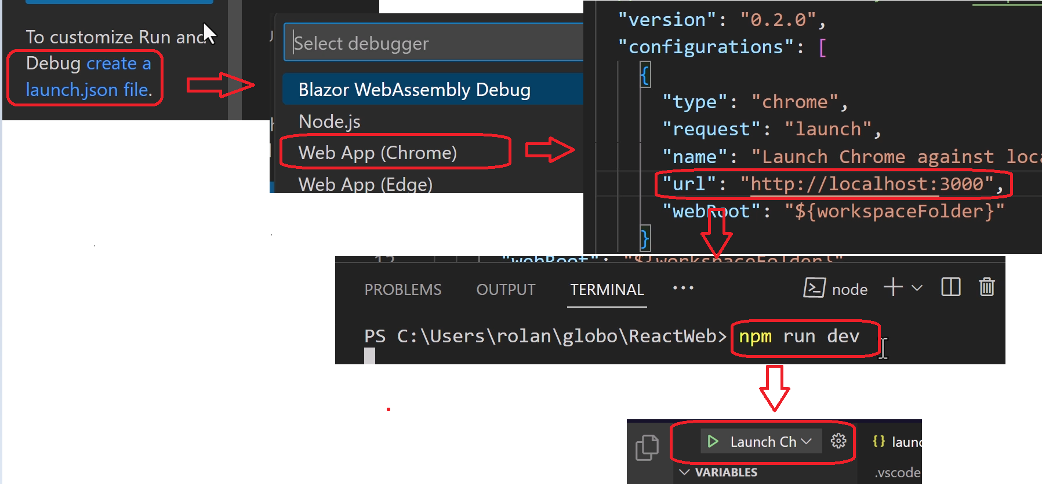

install package and Debugging .net

Install package
dotnet add package Microsoft.EntityFrameworkCore.Design --version 8.0.3
dotnet add package Microsoft.EntityFrameworkCore.Sqlite --version 8.0.3
dotnet add package Microsoft.EntityFrameworkCore.SqlServer --version 8.0.3

debug
Postavi break point in
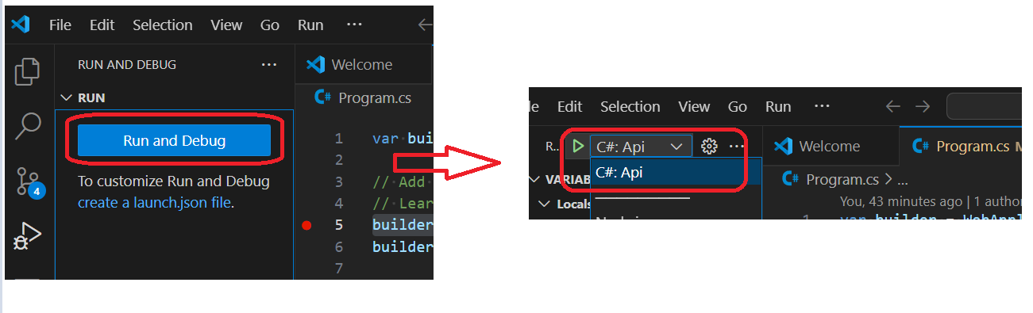

tmp links
https://www.linkedin.com/pulse/aspnet-core-api-code-first-approach-entity-framework-innet-indika-qwhrc

Links
Home:
https://app.pluralsight.com/library/

git clone:
https://github.com/RolandGuijt/ps-globomantics-webapi-react.git

Current
3-→API: Creating Database

